**Frontex supports seizure of cocaine by Portuguese authorities**

2019-02-01

Earlier this week, Portuguese Polícia Judiciária seized 2.5 tonnes of cocaine from a ship 200 nautical miles from the Portuguese coast with the support of Frontex, the European Border and Coast Guard Agency and Maritime Analysis and Operations Centre (MAOC-N).  
  
The cocaine was hidden in 82 bags on board an offshore supply ship and is worth an estimated EUR 125 million.

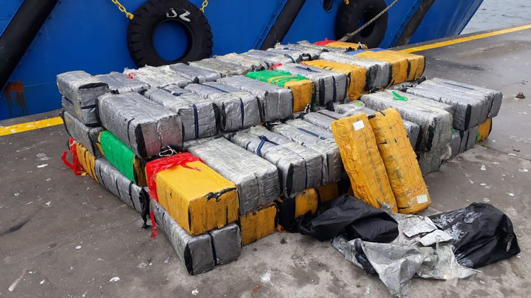

Frontex supported the operation as part of a pilot project that provides EU member states with technical, operational and financial assistance in combating cross-border crime, particularly drug smuggling, by sea.  
  
This particular project focuses on counteracting the cocaine smuggling from South America and hashish smuggling from Africa. Frontex also supported the operation run by the Portuguese authorities with its analytical capabilities.  
  
An investigation by the Portuguese authorities is ongoing.